**DS MINI PROJECT**

**Name of the project**:

Student Database using Linked list.

Made By:

Ajay Nadar

**Problem Definition**:

For Implement the Mini Project of Student Database using Linked list It should be able to perform the following functions-

a. Creation of Student Database in memory containing student roll no, First Name, Last Name, Address, Contact No and Date of Birth .

b. Insertion of student record by student roll no.

c. Deletion of student record by student roll no.

d. searching of student record by student roll no.

c. Display the record

Description-

A coordinated and efficient office arrangement is fundamental for all colleges and associations. There are numerous branches of organization for the support of school data and understudy information bases in any foundation. Every one of these offices give different records with respect to understudies. The vast majority of these histories need to keep up data about the understudies. This data could be the overall subtleties like understudy name, address, date of birth, contact no. and so on or explicit data identified with divisions like assortment of information.

All the modules in school organization are related. They are looked after physically. So they should be mechanized and unified as, Information from one module will be required by different modules. For instance when an understudy needs his course fruition declaration it needs to check numerous insights regarding the understudy like his name, reg number, year of study, tests he joined in and numerous different subtleties. So it needs to contact all the modules that are office, division and assessment and aftereffect of understudies.

In light of that, we updated the current Student Database Management System and made essential improvement to smooth out the cycles. Heads utilizing the framework will locate that the way toward recording and recovering understudies data and dealing with their classes, including checking of participation, is currently a breeze. When all is said in done, this task means to improve effectiveness and simultaneously keep up data precision. Later in this report, highlights and improvement that permit accomplishment to this objective will be exhibited and featured.

Our work is helpful for simple UI. We are wanting to uttilize the ground-breaking information base administration, information recovery and information control. We will gives more straightforwardness to dealing with the information than physically keeping up in the records. Our work is helpful for saving significant time and decreases the tremendous administrative work.

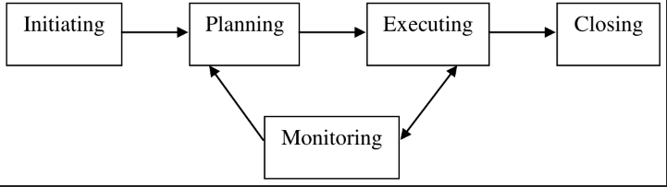

Project management skills are put to good use for this project. Project management focuses on achieving the objectives by applying five processes presented in the above Figure.

**RESOURCES**

Systems Development Life Cycle (SDLC) is the most common process adopted to develop a project and not surprisingly, this project is following this model too. To be precise, waterfall model is being applied. Waterfall model is a sequential model process where the input of a phase actually results from the previous phase.

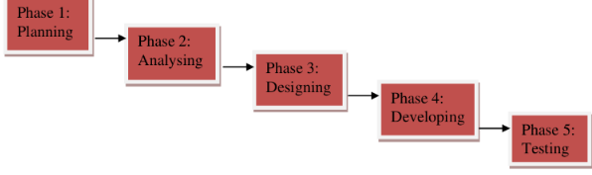

There are five phases in this model and the first phase is the planning stage. The planning stage determines the objectives of the project and whether the project should be given the green light to proceed. This is where the proposal submission comes into picture. After obtaining the approval, the next phase is analysis. Gathering and analysing the system and user requirements is essential for entry to the design step.

After deciding on the scripting language and database, the program analysis is started

**SYSTEM ANALYSIS AND DESIGN**

In order to provide a clearer picture of the functionality provided by the student management module, we have done a use case analysis.

Under the existing student management module, the administrator has to first register the details. This includes the roll number,  name ,etc . After submitting this Data we can perform all the provided operations like search, insert, delete.

**Result:**

Create:-

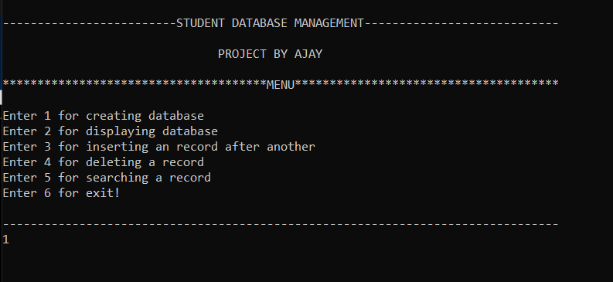

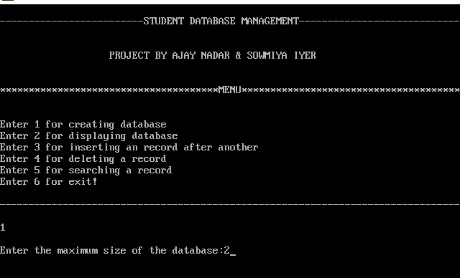

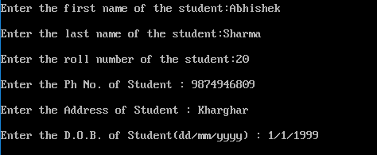

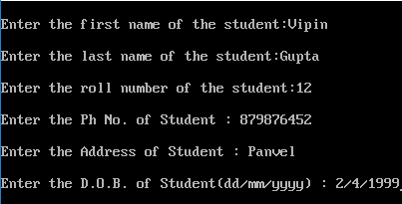

Display:-

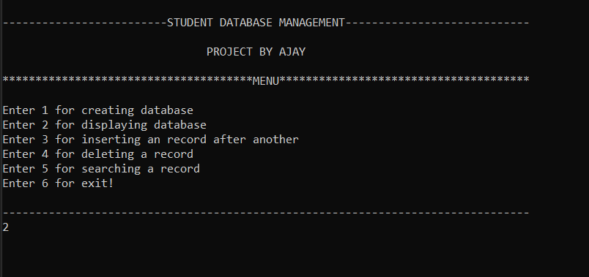

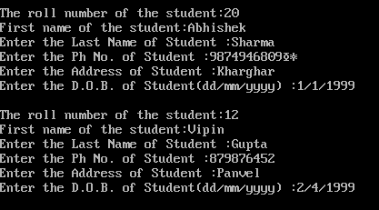

Inserting a record after another : -

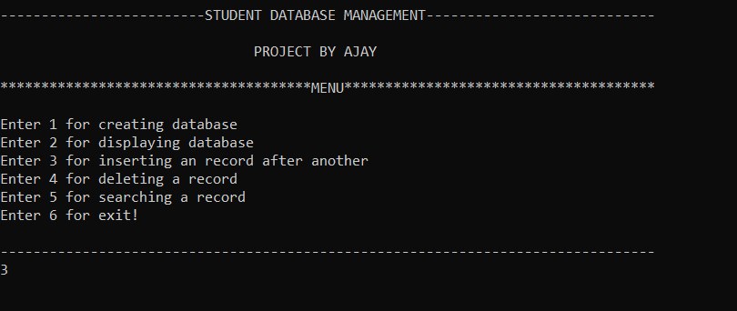

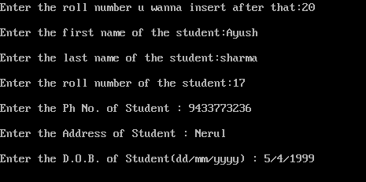

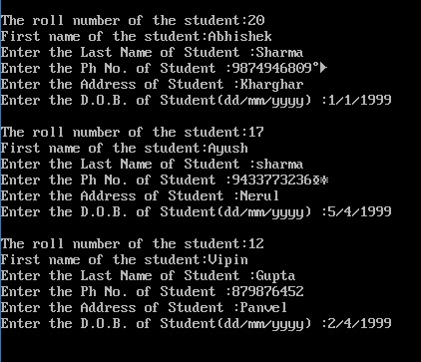

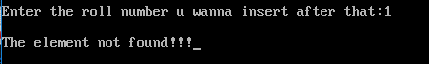

Deleting a record: -

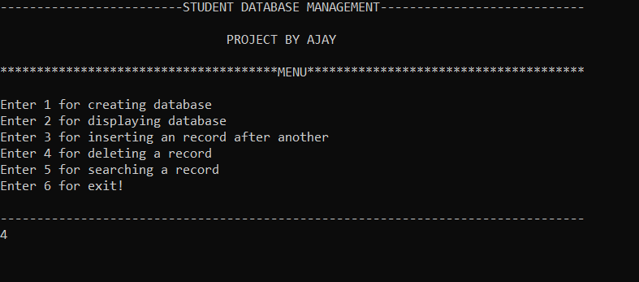



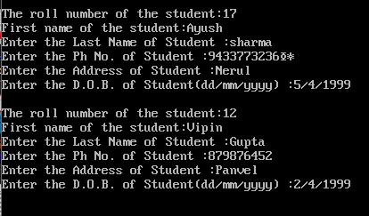

Searching a record:-

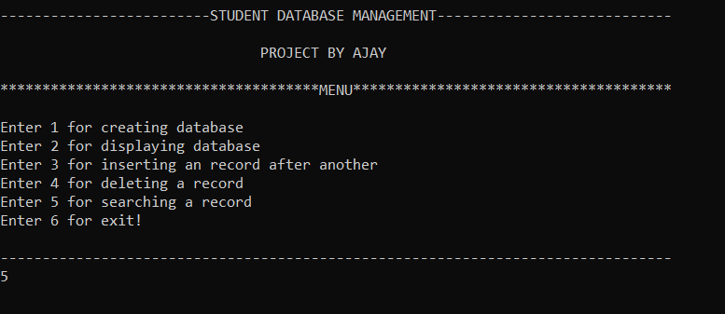

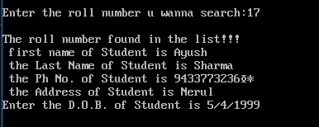



Exit:

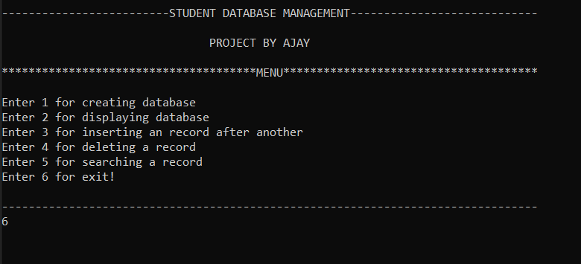

**Conclusion:**

The execution of the program was done successfully. A program to implement of student database management using Linked list was made.